ASSIGNMENT 2

1. pwd - Print Working Directory:

This command is used to print the current directory path in the terminal.

Example:

$ pwd

/home/acadgild

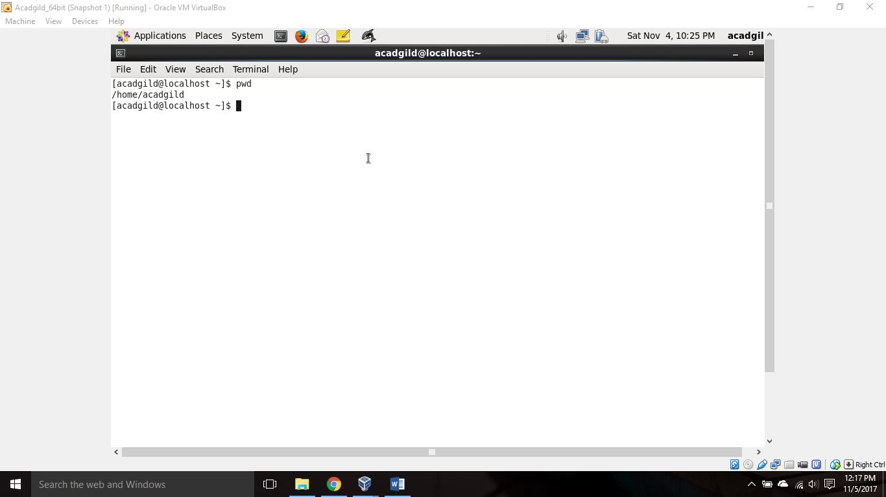

1. vi – Visual

It’s a text editor. This command followed by a file name (with optional extension) will create a new text file and opens it for adding contents. You need to press I (INSERT) to write something to a file. Once you are done with writing to a file, you can save it by pressing ESC key followed by colon+wq (:wq) and press Enter key. To exit editing mode without saving file contents: q!

You can view contents of a file by using the same command again. To modify existing contents of a file while you are viewing it, press I (INSERT mode), edit the file contents and save it once you are done.

Example:

$ vi sample_file.txt

Hi, this is Lingaraj.

Have a nice afternoon.

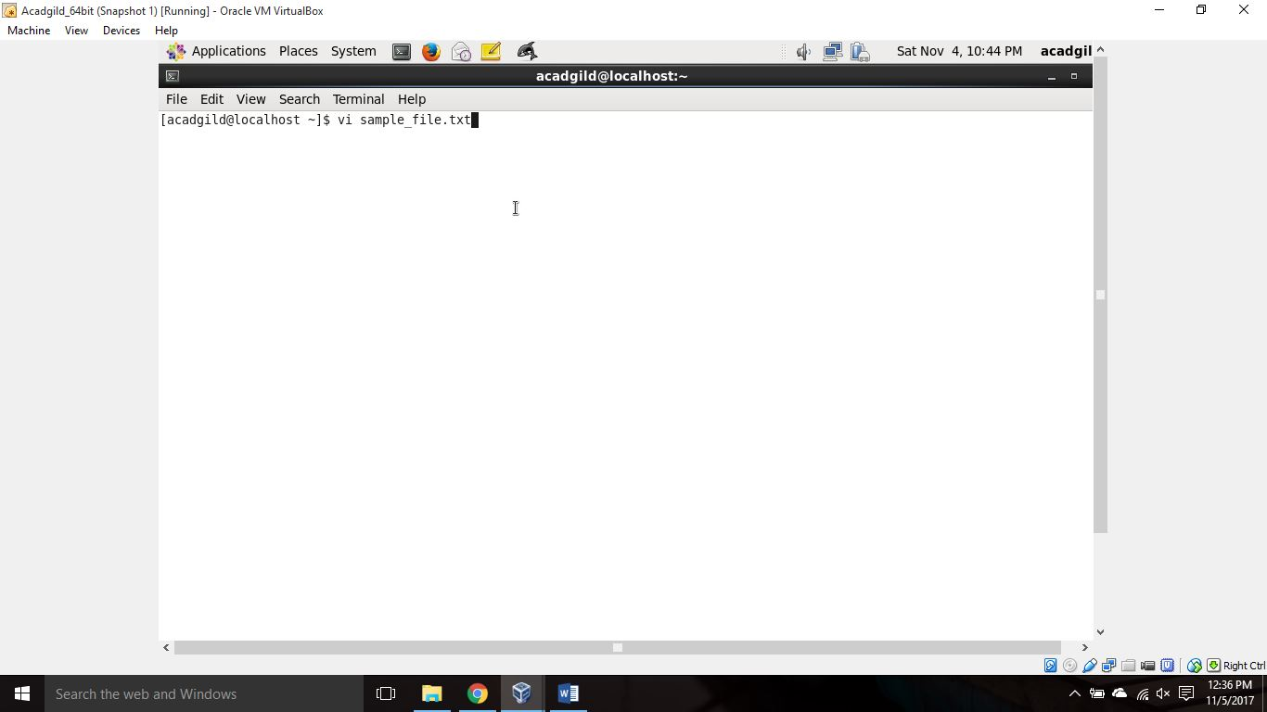

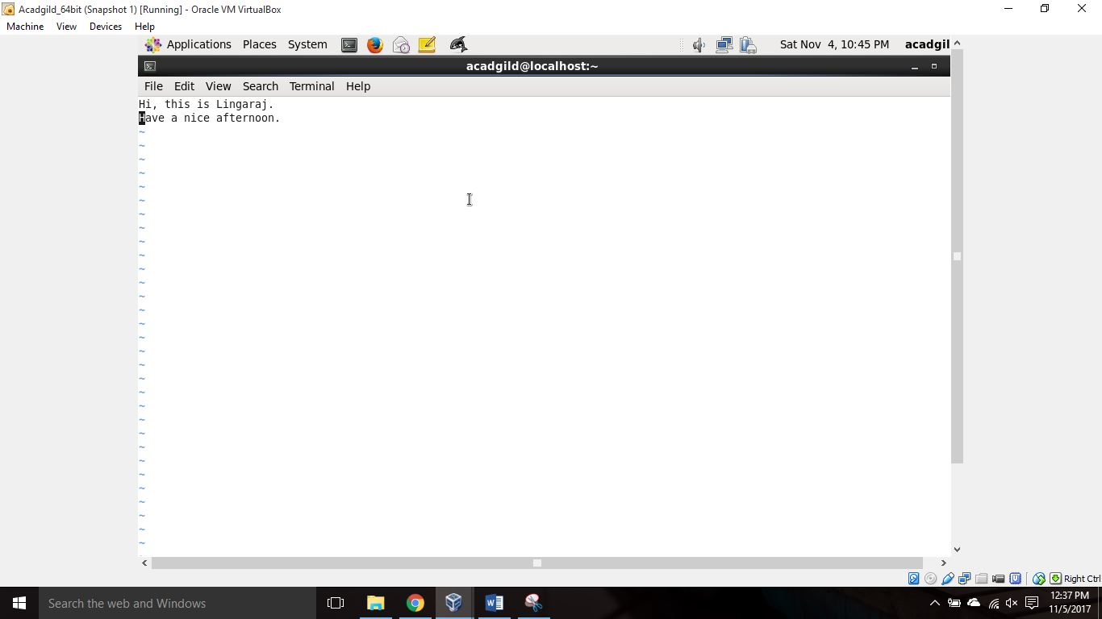

1. touch:

I haven’t used touch command so I am using help here.

$ touch –help

Usage: touch [OPTION]… FILE…

Update the access and modification times of each FILE to the current time.

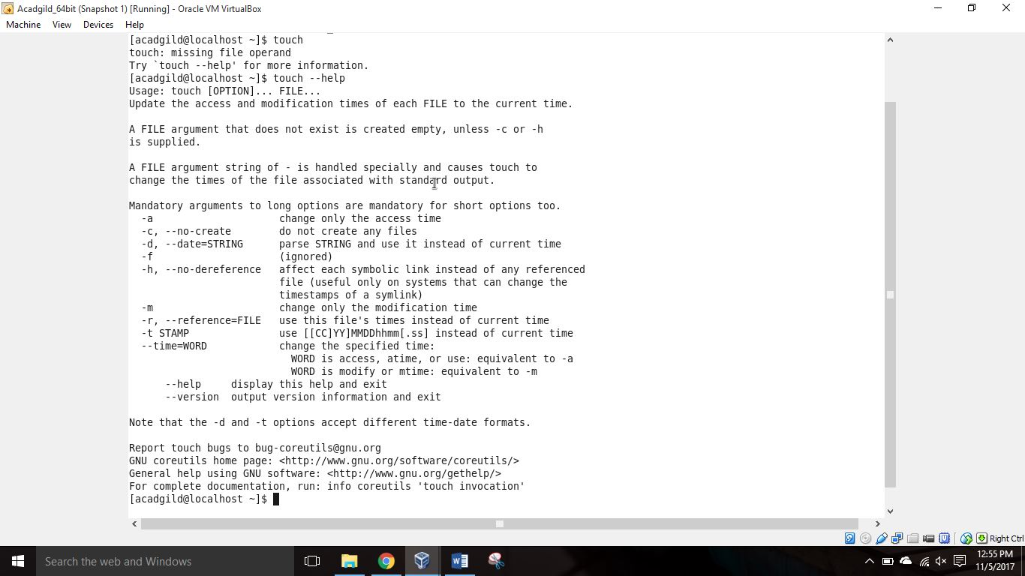

Example:

$ touch –a sample_file.txt -> Changes file access time to current time

$ touch –m sample_file.txt -> Changes file modification time to current time

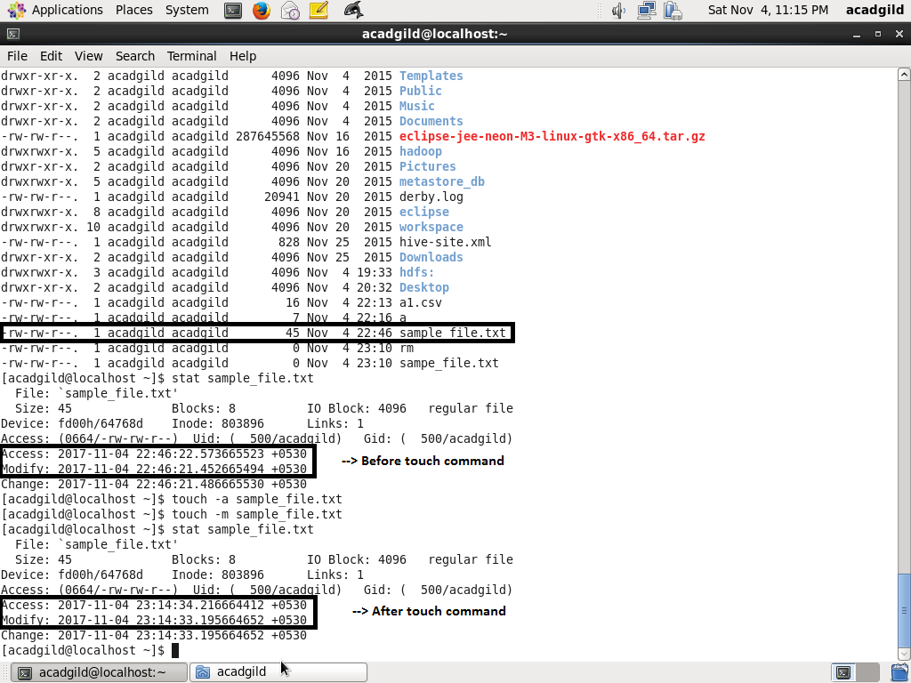

1. mkdir – make directory

This command is used to create a new directory in the current working directory.

Example:

$ mkdir myDir

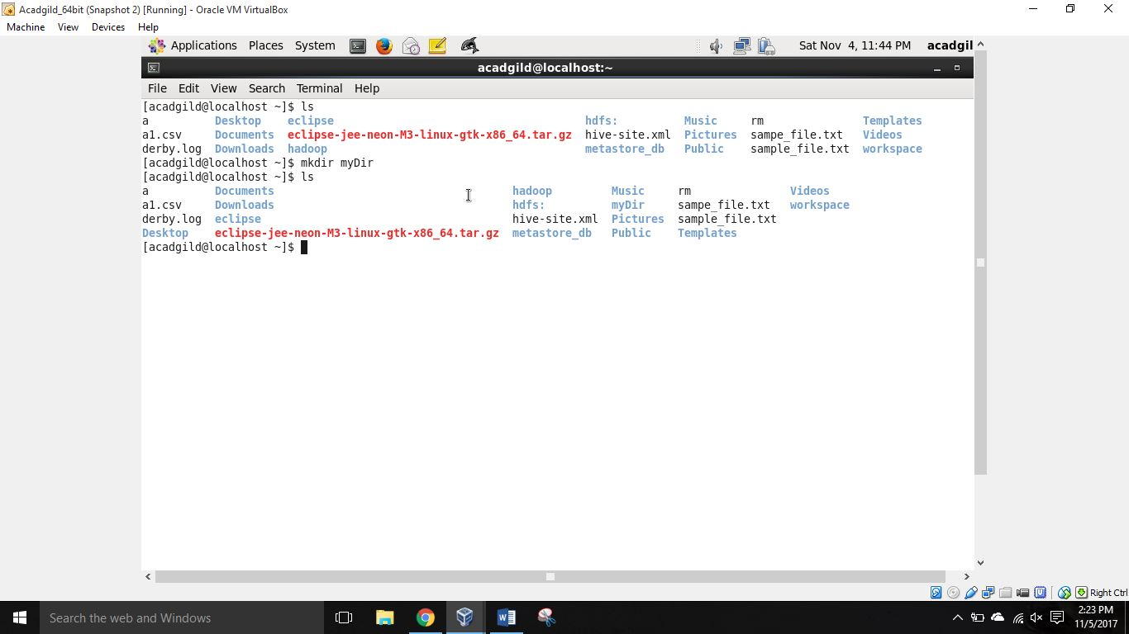

1. rm – remove command

This command is used to remove a file or a directory.

Example:

$ rm myFile -> deletes the file ‘myFile’ from file system.

$ rm –r myDir -> deletes the directory ‘myDir’ by recursively deleting all files and subdirectories

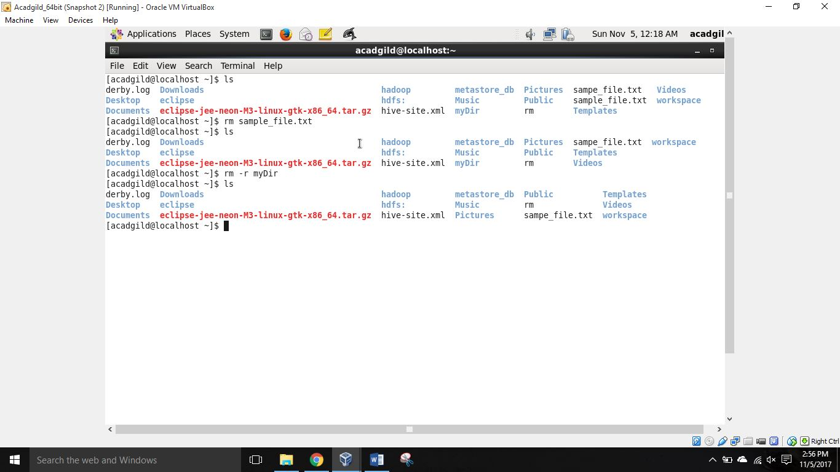

1. ls – list command

ls command is used to list all the contents of current directory or mentioned file system path.

ls –ltr -> uses a long listing format, sorts according to last modification time, sorts in reverse order.

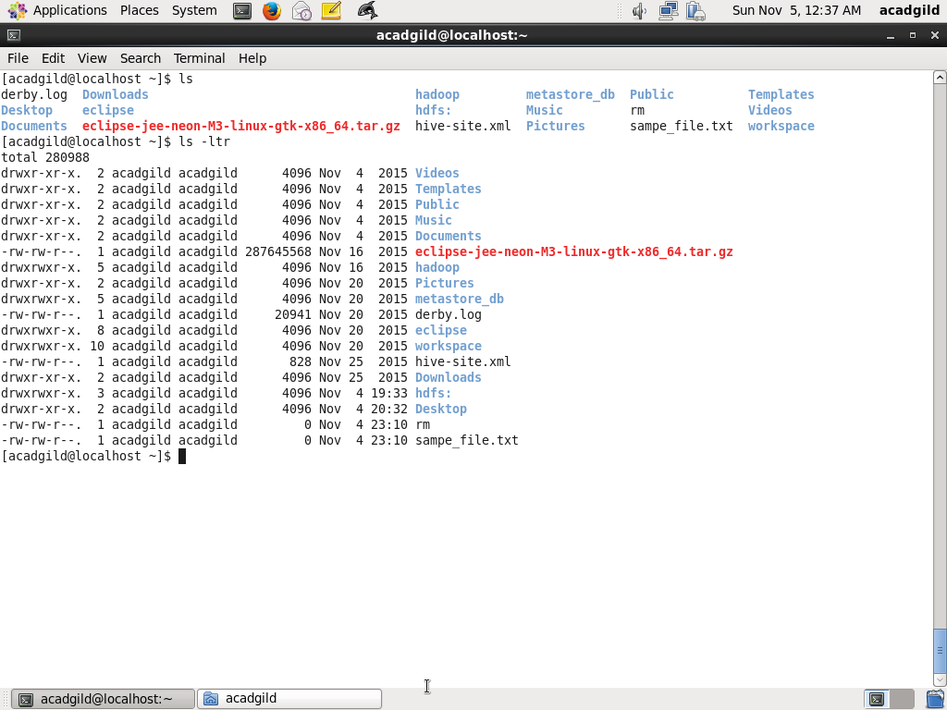

1. echo: this command is used to print a line of text on the console.

Example:

$ echo ‘Hello world!’

Hello world!

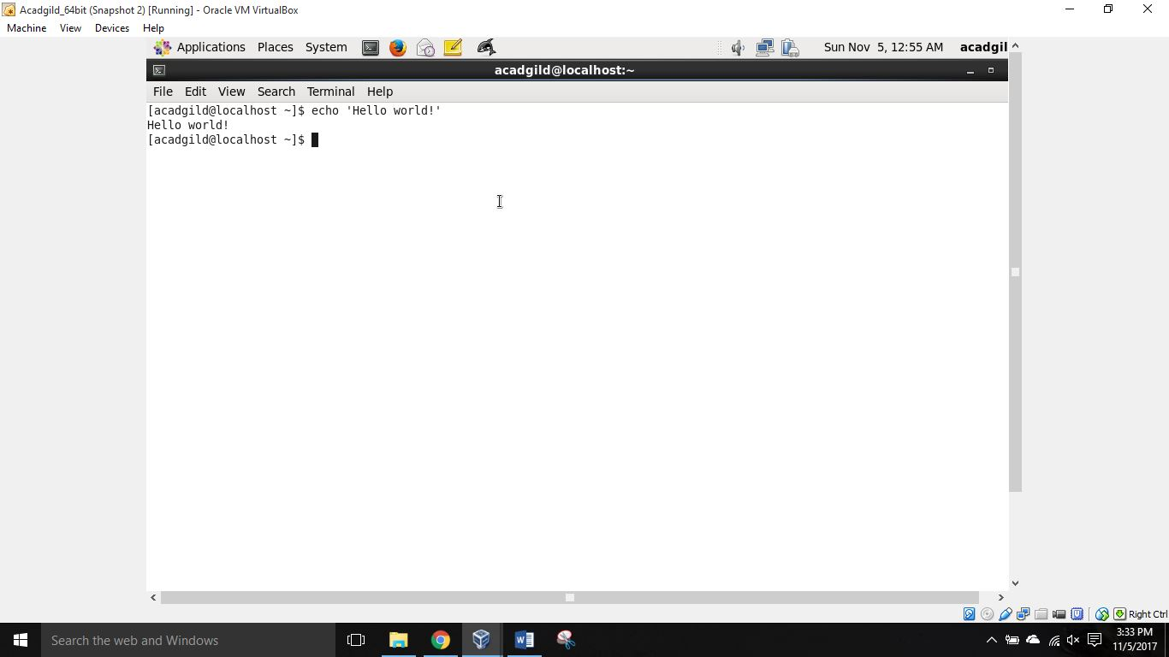

1. cat: cat command is used to display contents of a file to the console.

Example:

$ cat sample_file.txt

Hi, this is Lingaraj.

Have a nice afternoon.

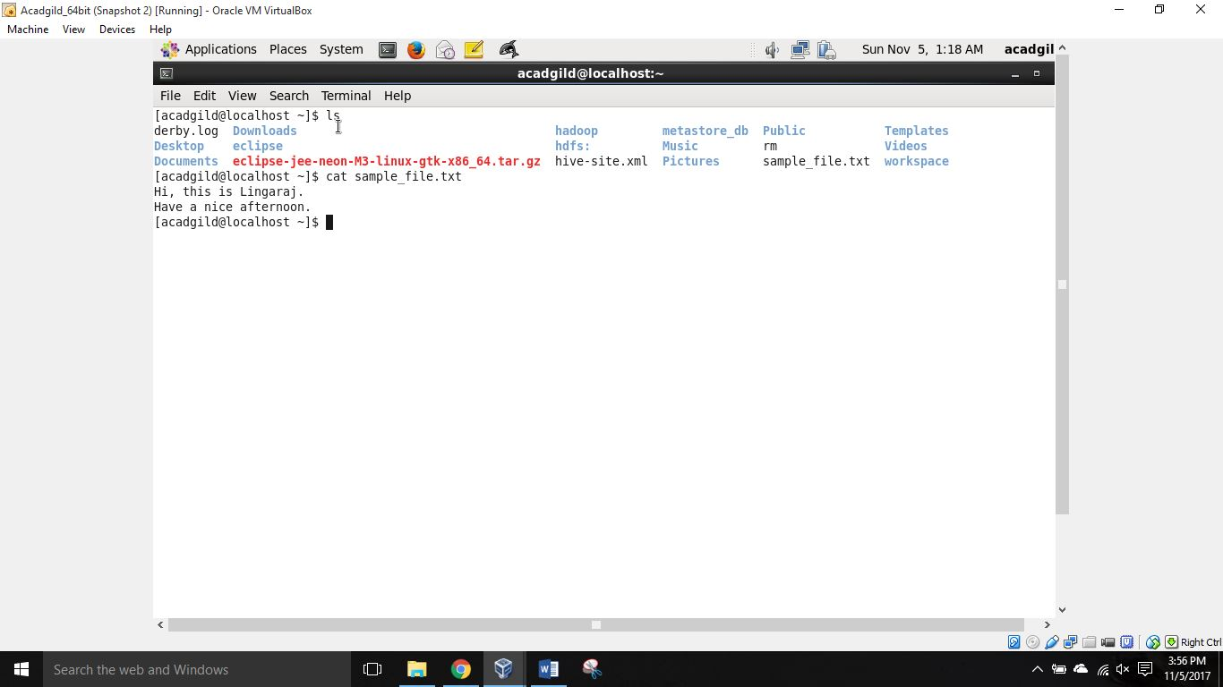

1. who: gives information about users who logged into the system.

Example:

$ who

acadgild tty1 2017-11-04 19:16 (:0)

acadgild pts/0 2017-11-04 22:12 (:0.0)

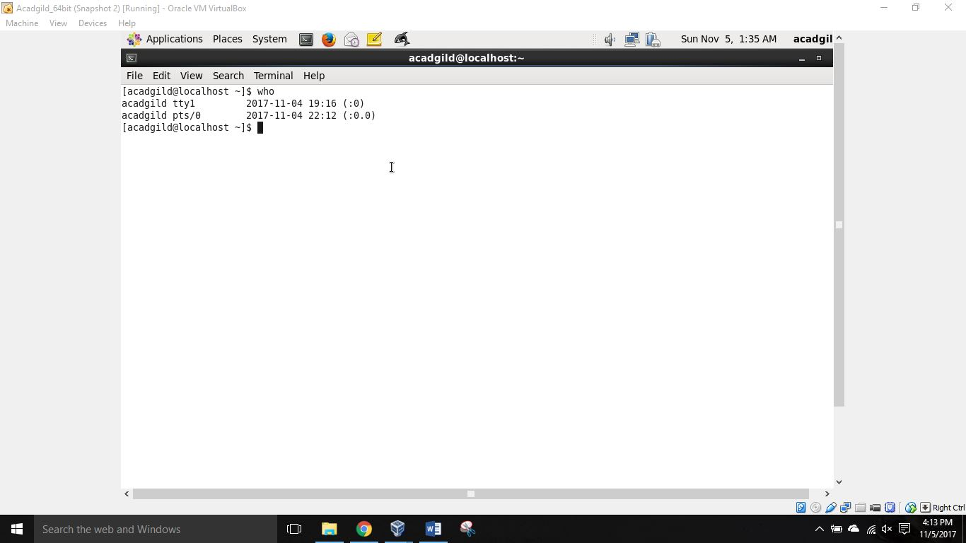

1. cd – change directory

As the name implies, cd command is used to change from one directory to another.

Example:

$ cd ./myDir -> redirects the user from current directory to the other directory ‘myDir’

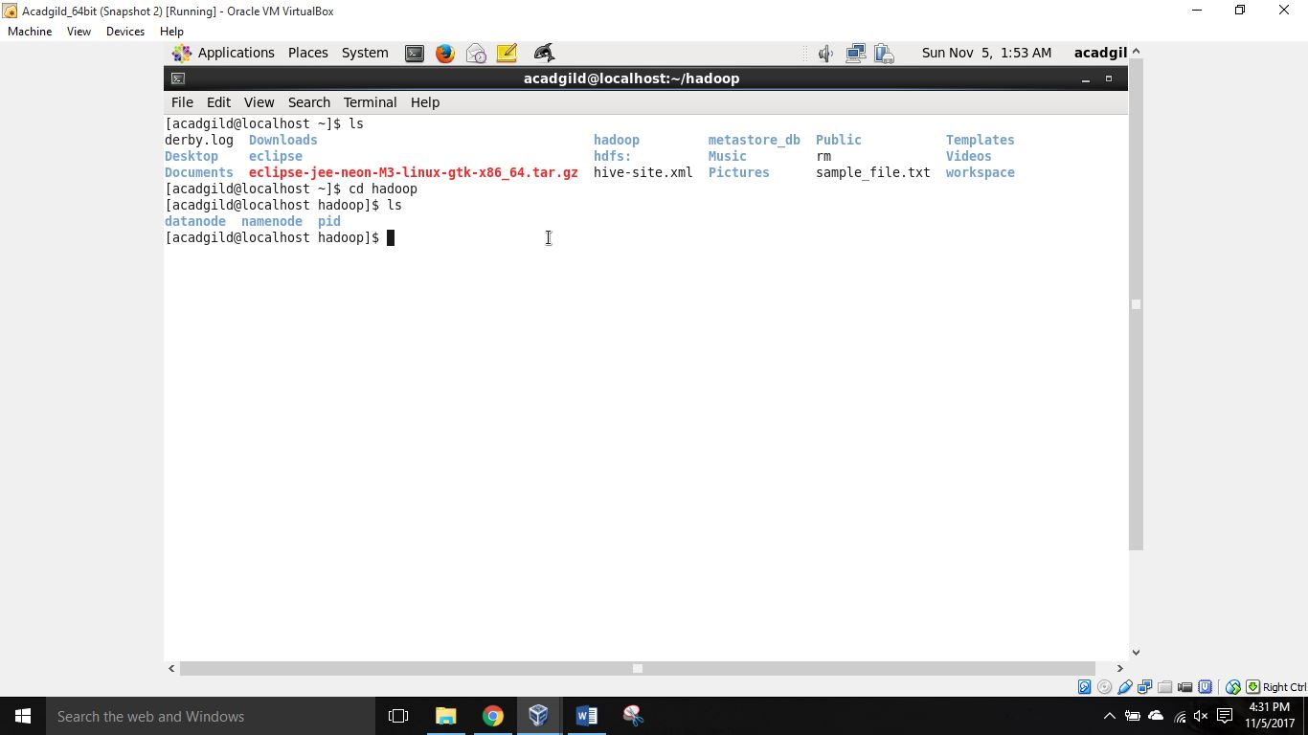

1. date: prints the timestamp (date and time) on the console.

Example:

$ date

Sun Nov 5 01:59:16 IST 2017

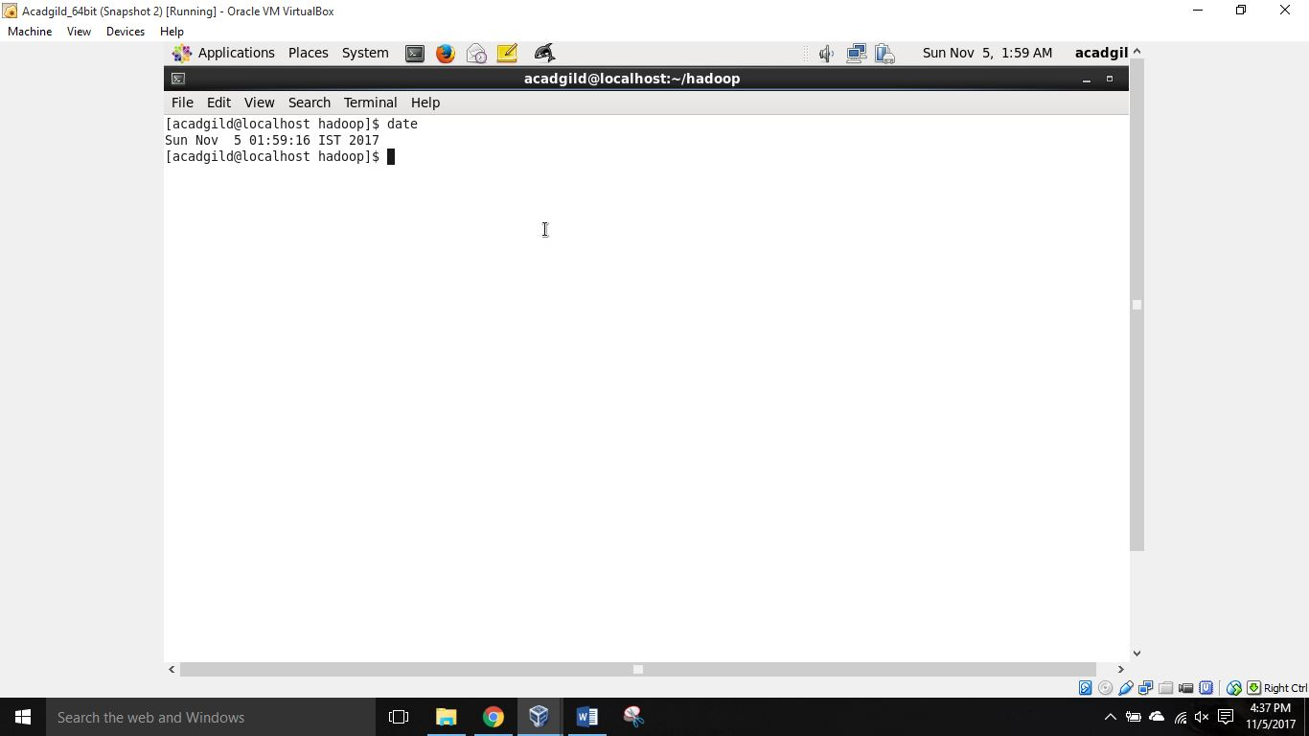

1. cal: It is used to display calendar on the console.

Example:

$ cal -> displays current month’s calendar

$ cal 8 2017 -> displays calendar for August 2017

$ cal -3 -> displays calendar for previous month, current moth and next month

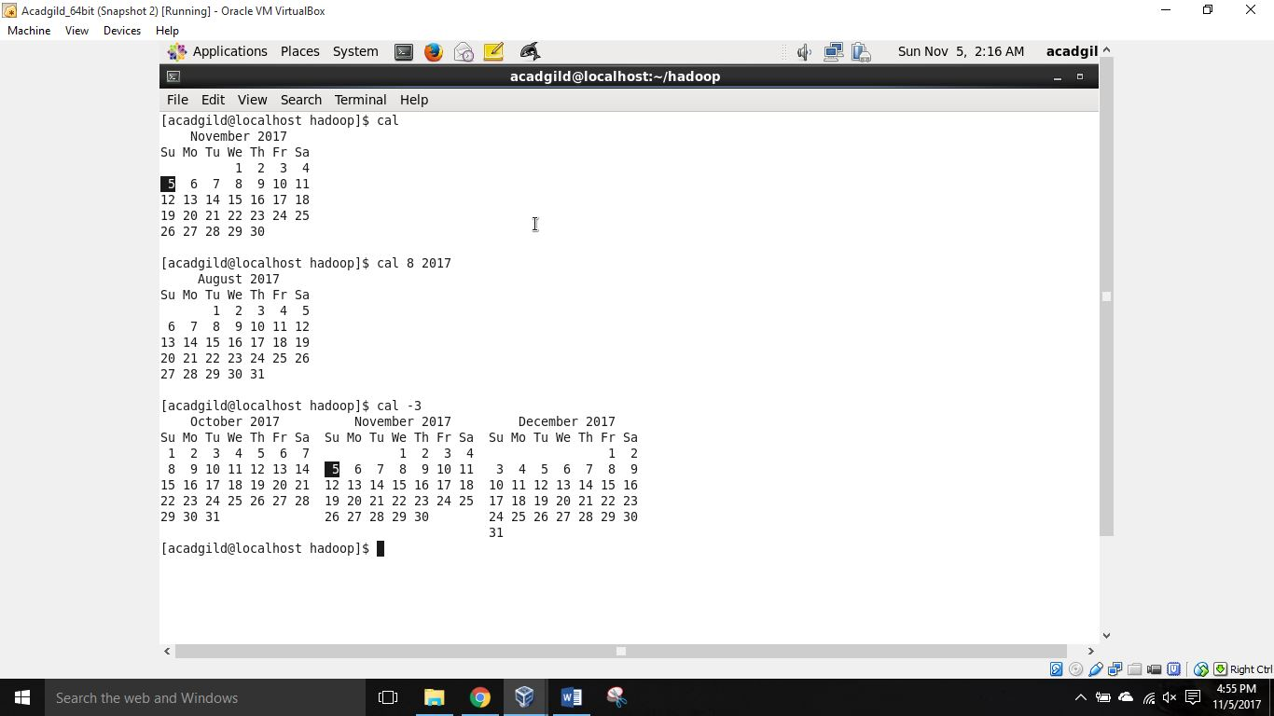

1. mv command moves, renames files and directories on a file system.

Example:

$ mv sample_file.txt sample.txt -> renames sample_file.txt to sample.txt

$ mv sample.txt ./myDir -> moves sample.txt file into directory ‘myDir’

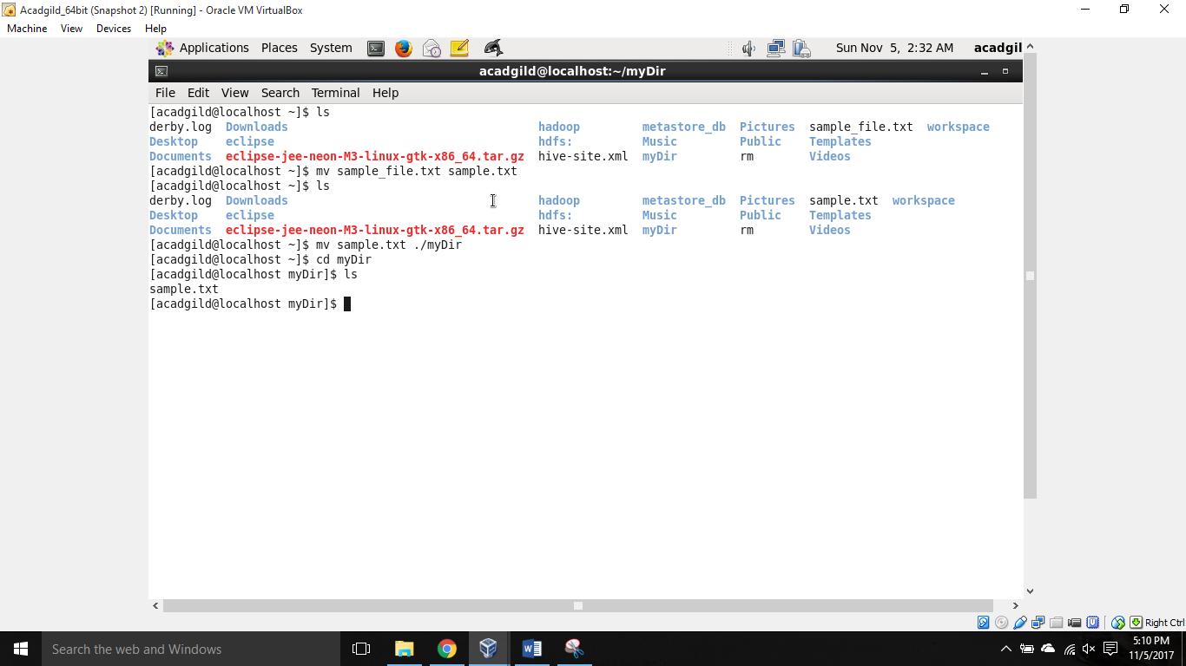

1. cp – copy command

It is used to copy a file or directory from one location in file system to another.

Example:

$ cp derby.log ./myDir -> copies file ‘derby.log’ to directory ‘myDir’

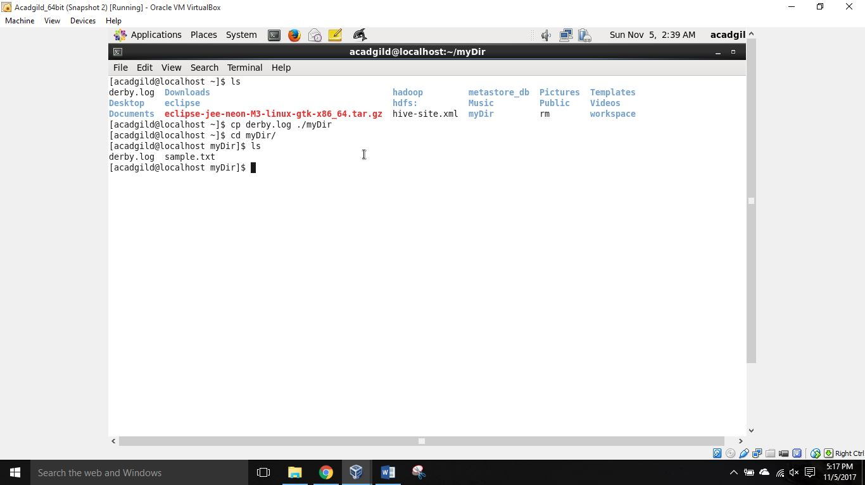

1. which:

Usage: /usr/bin/which [options] [--] COMMAND […]

Write full path of command to the standard output.

Example:

$ which –version

GNU which v2.19 …

GNU which comes with ABSOLUTELY NO WARRANTY;

This program is free software; your freedom to use, change

And distribute this program is protected by the GPL.

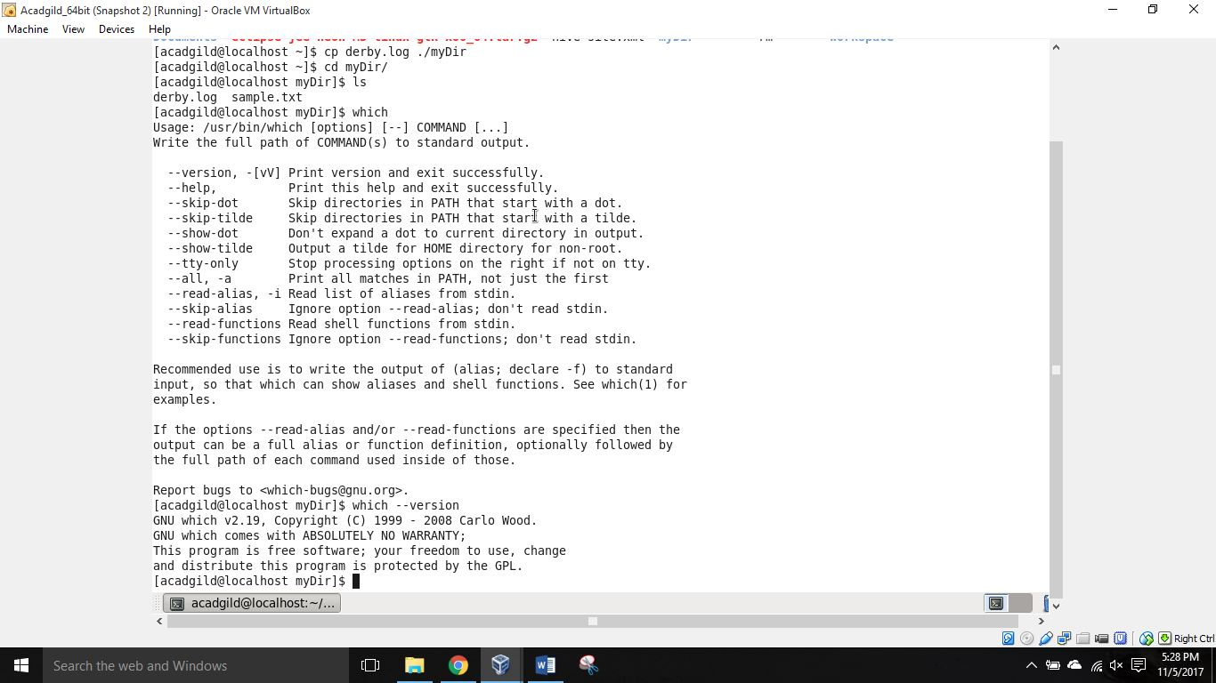

* END OF ASSIGNMENT -